CS-320 Module Seven Project 2 Summery Retrospective

Bruno F. Rivera Flores
Department of Computer Science, Southern New Hampshire University
CS-320: Software Testing, Automation 2026
Professor Jeff Phillips
April 16th, 2026

CS-320 Module Seven Project 2 Summery Retrospective
- Summary
- Describe your unit testing approach for each of the three features.
  - To what extent was your approach aligned to the software requirements? Support your claims with specific evidence.
- I follow the software requirements as instructed listed for each of the milestones given to me in the guidance and rubric section for Module 3, 4, and 5. I follow the code functionality requirements like ID not being updateable, leave it as a null value, to ensuring the IDs were uniquely generated for ContactService, TaskService, and AppointmentService classes. I also used previous milestones assignment codes as a foundation for time efficiency and modifying the code to match the rubric requirements. Same goes for writing up JUnit testing for each module assignment.
  - Defend the overall quality of your JUnit tests. In other words, how do you know your JUnit test were effective based on the coverage percentage?
- This is the part where I found the JUnit testing very neat. I right-clicked on the source package, make sure that I did a coverage as… JUnit test and concentrated on Coverage tab in the bottom part of the ellipse workspace where the results are next to the console tab. This is very important when it comes to Module 6 where in Project 1, we must combine all the classes and their Services and testing them to make sure that it reaches a 80% or higher coverage results. I noticed that, because at first, when I attempted only test coverage for Contact.java, then ContactService.java. It wasn’t adding up, it was giving According to the ContactServiceTest.java was giving us 81% and the Contact.java was giving us 0% results. This was combining all of the classes needed and then making the necessary changes afterwards.
- Describe your experience writing the JUnit tests.
    - How did you ensure that your code was technically sound? Cite specific lines from your tests to illustrate.
- Below I have a snippet of code I did if I must delete a contact based on the contact ID. I want to make sure that my code is technically sound when I create these JUnit testing by running it through various different testing scenarios that everything behaves with passing results. For example, the screenshot below shows not only the JUnit testing passing, but we are allowing to delete a contact if the contactId cannot be found, thus it becomes an IllegalArgumentException.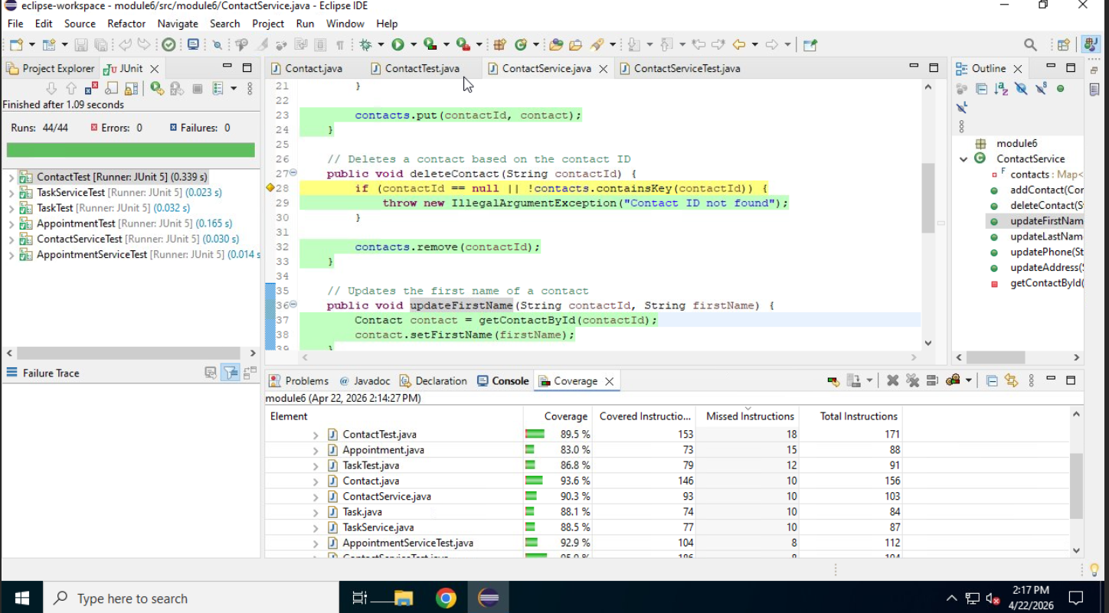

    - How did you ensure that your code was efficient? Cite specific lines of code from your tests to illustrate.
- I used one specific task for each method I wrote. This helps me keep track of what I am working with by organizing each line and flexible enough to be reused for future milestones and projects, saving us time efficient and streamlining faster results. For example, the screenshot below shows how I can use “throw now” commands to check the length of the phone number through validation and confirming the updated setter methods. We also stabilize our code by setting up a future appointment date and past date throwing an exception through the AppointmentServiceTest.java class. Commands like assertTrue, assertThrows helps us to check for valid and invalid behaviors.
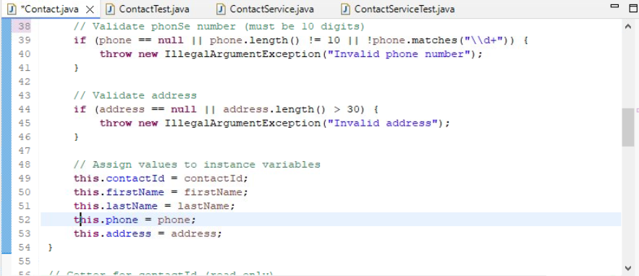
- Reflection
- Testing Techniques
    - What were the software testing techniques that you employed in this project? Describe their characteristics using specific details.
- I use unit testing as part of my software testing techniques. I want to make sure that these updates, deletions, and creation scenarios run correctly and allow me to check each method on its own. These techniques allowed me to run multiple tests, caught any errors that could cost us runtime problems.
    - What are the other software testing techniques that you did not use for this project? Describe their characteristics using specific details.
- As I done more research, more examples of other software testing techniques I could have used were examples like boundary value testing. Testing allowed me to run exact, input limits. In my milestone assignments, I could be using 20-character task names or 50-character appointment descriptions. These are especially useful where input limits matter like fields in the financial and healthcare software (Beizer, 1995). Other examples can be integration testing which is integrating systems with another to make sure that different components are working together as it is supposed to. And Regression testing. Testing that allows the system to ensure no new bugs or errors show up after changes has been made.
    - For each of the techniques you discussed, explain the practical uses and implications for different software development projects and situations.
- Regression testing is useful, because it can be conducted at any time when there is a change being made for the code to make sure there are no errors when it is being introduced with the update. With constant updates of the software, this test offers seamless transitions. In the development of lifecycle’s early stages, we can use Unit testing. We conducted these tests as early as Module 3. It is a great line of defense, because it tests different units of the system that each performs as in their intended function. And finally, we got integration testing. It is a useful way to catch defects early which will save us time and resources. It performs ensuring that different modules of code are working together with no error. Then code should be able to meet all requirements.

- Mindset
- Assess the mindset that you adopted working on this project. In acting as a software tester, to what extent did you employ caution? Why was it important to appreciate the complexity and interrelationships of the code you were testing? Provide specific examples to illustrate your claims.
- I was careful going into these modules, I was worried about how I am going to get started on these assignments. Similarly to writing a book, the toughest is starting it from scratch. In this case, write the source code from scratch. It is one of the reasons that I requested help from my instructor and got an idea on where I can get started on. Learning the complexity of each piece of code, then testing these relationships and behaviors and how essential they were.
- Assess the ways you tried to limit bias in your review of the code. On the software developer side, can you imagine that bias would be a concern if you were responsible for testing your own code? Provide specific examples to illustrate your claims.
- I took advantage of the guidelines and rubric out of each module and used it as a checklist covering each of the clients’ requirements. These extensive tests helped me fulfill the requirements out of each module. I was worried about testing my own code, especially when you first got started. However, I reused the previous blueprint or the foundation of code from Module 3 and grew it from there, expand, and made the necessary changes to where it has a 91% coverage in Module 6 Project 1 assignment.
- Finally, evaluate the importance of being disciplined in your commitment to quality as a software engineering professional. Why is it important not to cut corners when it comes to writing or testing code? How do you plan to avoid technical debt as a practitioner in the field? Provide specific examples to illustrate your claims.

- A great software engineering professional never stops asking questions. A commitment stays in constant communication and staying up to date with the latest changes to projects and assignments. This along with having quality code and not cutting corners will accomplish a better user experience, better reputation, and save time and money. I plan to continue pushing myself to learn new techniques with strong fundamentals and maintain best coding practices and principles.

References
Beizer, B. (1995). Software testing techniques (2nd ed.). Dreamtech Press.
https://daneshjavaji.wordpress.com/wp-content/uploads/2018/02/software-testing-2nd-edition.pdf

